**NATURAL LANGUAGE PROCESSING**

**Km Swati Gupta(jv-u/16/9122)** , **Pragya Nimbark(jv-u/16/9115)**

( Department of Computer Science and Electronics in Engineering, Jayoti

Vidyapeeth Women’s University, Jaipur, India)

**ABSTRACT-**

Natural language processing is a part of software engineering and computerized reasoning which is worried about association among PCs and human languages. Natural language processing is the investigation of numerical and computational demonstrating of different parts of language and the improvement of a wide scope of frameworks. These incorporates the expressed language frameworks that coordinate discourse and characteristic language. Common language handling has a job in software engineering on the grounds that numerous parts of the field deal with linguistic features of calculation.

Natural language processing (NLP) has as of late increased much consideration for speaking to and breaking down human language computationally. It has spread its applications in different fields for example, machine interpretation, email spam identification, data extraction, synopsis, therapeutic, and question noting and so on. The paper recognizes stages by talking about diverse dimensions of NLP , Natural Language Generation (NLG), its application and future scope.

**Keywords-** Natural language Processing, Natural Language Generation, Natural Language Understanding.

**1. INTRODUCTION**

**1.1 Natural Language Processing**

The field of concentrate that centers around the associations between human language and PCs is called Natural Language Processing, or NLP for short. Natural Language Processing, generally abbreviated as NLP, is a part of man-made reasoning that bargains with the collaboration among PCs and people utilizing the characteristic language. It sits at the convergence of software engineering, man-made brainpower, and computational phonetics. The first NLP was designed in 1950.

Most NLP strategies depend on machine figuring out how to get importance from human languages. It is a part of man-made brainpower that bargains with the collaboration among PCs and people utilizing the characteristic language. The extreme goal of NLP is to peruse, unravel, comprehend, and understand the human dialects in a way that is profitable.

Natural Language Processing can be classified into two **Natural Language Understanding** and **Natural Language Generation** .

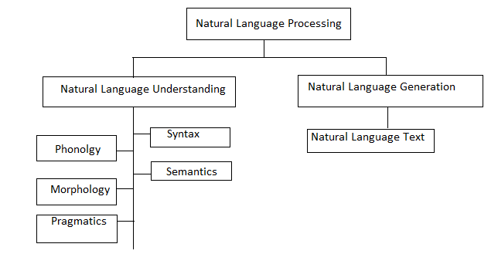

Figure: Broad Classification of NLP

**1.2 Natural Language Understanding**

Once in a while utilized conversely with NLP, NLU is really a subset of the comprehension and understandings bit of NLP. NLU is really the part of the innovation that deciphers human language into machine language. This is the initial phase in handling; understanding what the human is stating, what they are teaching the machine to do or the inquiry they are inquiring.

People are ordinarily ready to see each other when they talk a similar language. This is genuine notwithstanding when words are misspoke or slang is utilized. Machines, then again, are better at unsurprising circumstances.

**1.3 Levels in NLP**

* **Phonology** − It is investigation of sorting out sound efficiently.
* **Morphology** − It is an investigation of development of words from primitive important units.
* **Morpheme** − It is primitive unit of meaning in a language.
* **Syntax-** It alludes to masterminding words to make a sentence. It additionally includes deciding the basic job of words in the sentence and in expressions.
* **Semantics-** It is worried about the importance of words and how to consolidate words into significant expressions and sentences.
* **Pragmatics** − It manages utilizing and understanding sentences in various circumstances and how the translation of the sentence is influenced.
* **Discourse** -It manages how the quickly going before sentence can influence the understanding of the following sentence.
* **World Knowledge** − It incorporates the general learning about the world.

**1.4 Natural Language Generation**

Human languages offers a boundless method for saying a similar thing in various ways. Human languages never fits in with a characterized content or configuration. A solitary human may, at various occasions, type distinctive messages to express a similar thought. Once in a while human languages is theoretical or uncertain, particularly amid normal discussions.

NLG frameworks react to human languages with canny, clear reactions that are valuable and bode well. Through the most recent profound learning calculations, NLG frameworks can understand questions and issues and react with canny answers. Basically, NLG creates content from information that has been prepared through NLP and NLU.

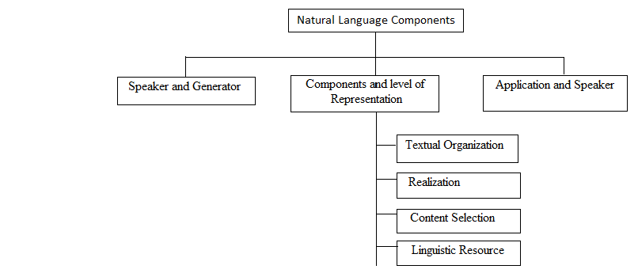

Figure: Components of NLG

* **Speaker and Generator** – To produce a content we need a speaker or an application what's more, a generator or a program that renders the application's expectations into familiar expression pertinent to the circumstance.
* **Components and Levels of Representation** - The procedure of language age includes the accompanying joined undertakings. Content choice: Information ought to be chosen and incorporated into the set. Contingent upon how this data is parsed into illustrative units, parts of the units may must be expelled while some others might be included as a matter of course.

**Textual Organization**: The data must be literarily sorted out agreeing the syntax, it

must be requested both consecutively and as far as semantic relations like

adjustments.

**Linguistic Resources**: To help the data's acknowledgment, etymological assets must be picked. At last these assets will come down to decisions of specific words, figures of speech, syntactic builds and so forth.

**Realization**: The chose and sorted out assets must be figured it out as a genuine content or voice yield.

* **Application or Speaker** – This is just to keep up the model of the circumstance. Here the speaker just starts the procedure doesn't partake in the language age. It stores the history, structures the substance that is conceivably applicable and sends a portrayal of what it really knows. All these frame the circumstance, while choosing subset of recommendations that speaker has. The main necessity is the speaker needs to comprehend the circumstance.

**2. Steps in NLP**

There are basically five steps

* **Lexical Analysis** − It includes recognizing and breaking down the structure of words. Vocabulary of a language implies the gathering of words and expressions in a language. Lexical examination is partitioning the entire piece of text into sections, sentences, and words.
* **Syntactic Analysis (Parsing)** − It includes examination of words in the sentence for language structure and orchestrating words in a way that demonstrates the relationship among the words.
* **Semantic Analysis −** It draws the correct importance or the word reference significance from the content. The content is checked for weightiness. It is finished by mapping syntactic structures and items in the undertaking area.
* **Discourse Integration** − The significance of any sentence relies on the importance of the sentence just before it. Moreover, it additionally achieves the significance of promptly succeeding sentence.
* **Pragmatic Analysis** − During this, information disclosed is re-deciphered on what it really implied. It includes inferring those parts of dialect which require genuine learning.

**3. Applications of NLP**

* **Machine Translation -** As the measure of data accessible online is developing, the need to get to it turns out to be progressively essential and the estimation of common dialect handling applications turns out to be clear. Machine interpretation encourages us overcome dialect hindrances that we regularly experience by deciphering specialized manuals, bolster substance or indexes at an altogether decreased expense. The test with machine interpretation advances isn't in deciphering words, yet in understanding the significance of sentences to give a genuine interpretation.
* **Automatic summarization-** Data over-burden is a genuine issue when we have to get to a particular, imperative snippet of data from a gigantic learning base. Programmed outline is pertinent not just to abridge the importance of archives and data, yet in addition for comprehend the passionate implications inside the data, for example, in gathering information from online networking. Programmed outline is particularly pertinent when used to give a review of a news thing or blog entries, while maintaining a strategic distance from repetition from different sources and amplifying the assorted variety of substance acquired.
* **Sentiment analysis**- The objective of estimation examination is to recognize slant among a few posts or even in a similar post where feeling isn't in every case unequivocally communicated. Organizations utilize characteristic dialect handling applications, for example, feeling investigation, to recognize opinions and assumption online to enable them to comprehend what clients consider their items and administrations , and large markers of their notoriety. Past deciding basic extremity, assumption investigation comprehends assessment in setting to enable you to all the more likely comprehend what's behind a communicated supposition, which can be incredibly significant in understanding and driving buying choices.
* **Text classification-** Text classification makes it conceivable to dole out predefined classes to a record and sort rout it to enable you to discover the data you require or improve a few exercises. For instance, an utilization of content classification is spam sifting in email.
* **Question Answering**- As discourse understanding innovation and voice-input applications enhance, the requirement for NLP will just increment. Question-Answering (QA) is winding up increasingly more mainstream because of utilizations, for example, Siri, OK Google, talk boxes and menial helpers. A QA application is a framework prepared to do soundly noting a human demand. It might be utilized as a content just interface or as a verbally expressed exchange framework. While they offer extraordinary guarantee, despite everything they have far to go (investigate these video to perceive what happens when two spoken exchange frameworks converse with one another: https://youtu.be/WnzlbyTZsQY). This remaining parts a pertinent test particularly for web crawlers, and is one of the principle utilizations of normal dialect preparing research.

**4. Challenges For NLP**

* **Physical Limitations-**The best test to NLP is speaking to a sentence or gathering of ideas with outright accuracy. The substances of PC programming and equipment constraint make this test almost unconquerable. The practical measure of information important to perform NLP at the human dimension requires a memory space and preparing limit that is past even the most dominant PC processors.
* **No Unifying ontology-NLP experiences the absence of a bringing together cosmology that tends to semantic just as syntactic portrayal. The different contending ontologies serve just to moderate the headway of information the executives.**
* **No Unifying Semantic Repository-NLP does not have an available and complete learning base that depicts the world in the detail important for down to earth use. The best business learning bases are restricted to authorized use and have minimal shot of wide appropriation. Indeed, even those with the most scholarly expectations create at an unsatisfactory pace.**
* **Current Information Retrieval System-The execution of a large portion of the present data recovery frameworks is influenced by semantic over-burden. Web crawlers, restricted by their technique for ordering, as a general rule return off base matches because of equivocal translation.**

**5. Future Scope**

Influence PCs as they too can take care of issues like human and think like people and perform exercises that human can't perform and making it increasingly productive then people. Analyzing sentiments, smarter search, intelligence gathering, healthcare recordings at large scale can be done using NLP. It can be used in robotics and cars as well.

**6. Conclusion**

Natural language processing is a field of software engineering and AI that centers principally around the communication among PCs and people. The absolute first NLP was planned in 1950. Some genuine utilization of Natural Language Processing incorporate Apple's Siri and Microsoft's Cortana. The future of NLP is bright.

**7. References**

[1] Chomsky, Noam, 1965, Aspects of the Theory of Syntax, Cambridge, Massachusetts: MIT Press.

[2] Rospocher, M., van Erp, M., Vossen, P., Fokkens, A., Aldabe,I., Rigau, G., Soroa, A., Ploeger, T., and Bogaard, T.(2016). Building event-centric knowledge graphs from news. Web Semantics: Science, Services and Agents on the World Wide Web, In Press.

[3] Shemtov, H. (1997). Ambiguity management in natural language generation. Stanford University.

[4] Emele, M. C., & Dorna, M. (1998, August). Ambiguity preserving machine translation using packed representations. In Proceedings of the 36th Annual Meeting of the Association for Computational Linguistics and 17th International Conference on Computational Linguistics-Volume 1 (pp. 365-371). Association for Computational Linguistics.

[5] Knight, K., & Langkilde, I. (2000, July). Preserving ambiguities in generation via automata intersection. In AAAI/IAAI (pp. 697-702).

[6] Nation, K., Snowling, M. J., & Clarke, P. (2007). Dissecting the relationship between language skills and learning to read: Semantic and phonological contributions to new vocabulary learning in children with poor reading comprehension. Advances in Speech Language Pathology, 9(2), 131-139.

[7] Liddy, E. D. (2001). Natural language processing.

[8] Feldman, S. (1999). NLP Meets the Jabberwocky: Natural Language Processing in Information Retrieval. ONLINE-WESTON THEN WILTON-, 23, 62-73.

[9] "Natural Language Processing." Natural Language Processing RSS. N.p., n.d. Web. 25 Mar. 2017

[10] Hutchins, W. J. (1986). Machine translation: past, present, future (p. 66). Chichester: Ellis Horwood.

[11] Hutchins, W. J. (Ed.). (2000). Early years in machine translation: memoirs and biographies of pioneers (Vol. 97). John Benjamins Publishing.

[12] Green Jr, B. F., Wolf, A. K., Chomsky, C., & Laughery, K. (1961, May). Baseball: an automatic question-answerer. In Papers presented at the May 9-11, 1961, western joint IREAIEE-ACM computer conference (pp. 219-224). ACM.

[13] Woods, W. A. (1978). Semantics and quantification in natural language question answering. Advances in computers, 17, 1-87.